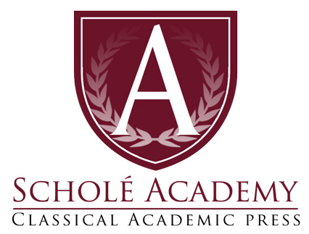
Upper School Mythology
Writing Intensive Course
Yearlong 2022-2023
ELIGIBLE STUDENTS:
Term: Yearlong 2022–23, September 7–May 26
Grade Level: Grades 11-12; 10th graders welcome
Schedule: 2x / week 60–75 min. Time: M/W 2:00 p.m. ET
Instructor: Weslea Bell
Class Dates: Begin Wednesday, September 7, 2022; running through Friday, May 26, 2023.
Section: 1
Course Map
Quarter 1
- Ancient Egypt, Babylon, and Assyria: Culture and Myths
- Ancient Incas and Mayans: Culture and Myths
Quarter 2
- Journeys and Origins of Greek and Roman Mythology
- Platonic Myths
- The Four Great Heroes
Quarter 3
- The Tragic House of Thebes
- The Tragic House of Atreus
- Love Lost and Found
Quarter 4
- Mythology in Literature, Art, and Film

OFFICE HOURS
In addition to scheduled class times, the teacher will generally designate an optional weekly session as needed. During “office hours” students may raise questions, seek assistance, or review class material.
REQUIRED COURSE TEXTS
The Myth Made Fact: Reading Greek and Roman Mythology through Christian Eyes by Dr. Louis Markos (may be purchased from Classical Academic Press; ISBN 9781600513954)
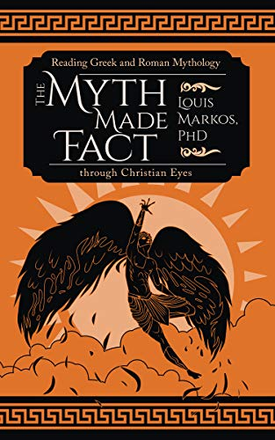

Till We Have Faces: Walking to Wisdom Literature Guide (Student Edition) (may be purchased from Classical Academic Press; ISBN: 9781600512469)
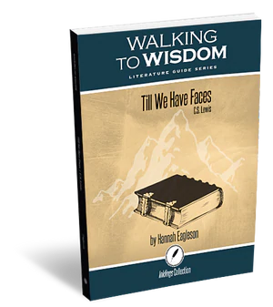
*Students also need reliable Internet access and access to either Google Docs or Microsoft Word for writing assignments.
*Students are welcome to use the format they prefer for the course texts: hard-copy version, Amazon Kindle version, or Apple ibook version. Students who use ebooks are encouraged to use a print version, as well, for annotations.

OPTIONAL COURSE TEXTS
Papers and essays will be submitted using basic MLA formatting guides. The MLA Hand- book for Writers of Research Papers: 7th Edition may be a helpful resource.
Upper School Mythology Course Description
Upper-School Mythology introduces students to fascinating tales of other worldly creatures, gods, goddesses, monsters, and warriors and invites them to explore life’s ultimate questions, like “Who am I?”, “Why am I here?” and “How can I live a virtuous life?”. Through an exploration of literature, history, philosophy, geography, and culture – all in one engaging course – students read mythological tales from a variety of geographical locations and historical time periods, reflecting on the customs, beliefs, and cultural perspectives of a survey of ancient civilizations, with a central focus on ancient Greece and Rome.
Using Dr. Louis Marko’s book, The Myth Made Fact: Reading Greek and Roman Mythology through Christian Eyes as the central text for the course, students are introduced to tales as expressions of the human condition, in both its virtue and its depravity, through a myriad of mythological personas and narratives. Markos invites students to view the myths as eloquent and poignant reflections of the limitations of man, who, despite his best creative and intellectual efforts, sees the world as the Apostle Paul described it, “through a glass darkly.” Similar to Paul walking along the marble streets before the temple of Artemis presenting Christ as the answer to the emptiness and longings of paganism, Markos walks students through ancient mythological stories illuminating the state of man as one of readiness for and anticipation of a Redeemer and a Savior.
In addition to The Myth Made Fact: Reading Greek and Roman Mythology through Christian Eyes, class participants also read Till We Have Faces, by C.S. Lewis. Lewis retells the myth of Psyche and Cupid from the perspective of Psyche’s sister, Orual. This book encourages students to experience through myth man’s fallibility and the manifestations of human wisdom and longing. C.S. Lewis said himself that he considered Till We Have Faces to be his best and most mature literary work. The complexity of the narrator as a character addresses the issues of agnosticism, romantic love, sacrifice, and redemption.
Upper School Mythology Scope and Sequence
Upper-School Mythology focuses mainly on classical Greeks and Romans, but also explores the lore and legends of other ancient empires, including both Mesoamerican and Mesopotamian cultures like the Incas, Mayans, Egyptians, Babylonians, and Assyrians. As a result of taking this course, students will recognize the influence of Mythology in classical literature and poetry, as well as in modern pop culture, exploring connections to things like Marvel superheroes, Pandora jewelry, and Nike sportswear, to name a few obvious examples. Students add depth and scope to their understanding and appreciation both of academia and of their own modern environment when they have a solid foundation in the study of Mythology and its far-reaching impact on today’s world.
STUDENT EXPECTATIONS: EXECUTIVE FUNCTION SKILLS
Students enrolling in Scholé Academy’s Logic Program will be expected to show development of Executive Function Skills throughout the year. Executive Function Skills speak to a set of qualities and skill sets students can develop and hone to better approach the courses, lectures, readings, and teachers they will face in their future academic coursework.
Each teacher will invariably have his own set of requirements and skills he requires students to bring to their studies. Generally speaking, there are five such qualities that are necessary for my students in various subjects:
1. An Engaged Student: One who is willing to step into the arena of class discussion, ask questions, supply answers, and generate the internal dialogue necessary to determine if what's being discussed is important and necessary to himself.
2. Note Taking: A student who, both during and after being engaged with the class, has been trained to note important and relevant content in an organized fashion (Cornell Notes would be a great option). His notes would then be consulted, independently, for application in assignments and assessments.
3. Attention to Detail & Preparedness: A student who consistently adheres to deadlines, submission requirements, and style guides and codes; confirms technology is working prior to the start of class; and is responsible to determine how to proceed after an absence, consulting the course syllabus and adjusting as the class proceeds, etc.
4. Employ Critiques: One who receives feedback on a submission and then is sure to apply that feedback to future assignments rather than repeating mistakes. Such a student also gleans information from the live class critiques of fellow students and notes mistakes to avoid by learning from others.
5. Initiative/Maturity: This student would hear the teacher’s comments and be able to assess whether the teacher was describing his work, and then take the initiative to schedule office hours with his teacher if necessary.
STUDENT EXPECTATIONS IN ACTION
Discussion is an integral part of Upper-School Mythology, and students are expected to come to class having completed the two to three hours of assigned readings for the week. The Myth Made Fact: Reading Greek and Roman Mythology through Christian Eyes includes discussion questions at the end of each myth that give students an opportunity to explore deep topics and insights through live conversation with their classmates.
Writing assignments are a regular part of Upper-School Mythology and range in length from single paragraphs to essays of 500-700 words, formatted according to the standards of MLA Style. Students are instructed in the correct usage of direct quotations, summaries, and paraphrases from the two course texts as tools for expressing their own points of view. Originality and creativity are encouraged as students are taught the process of responsive essay writing as a means of engaging with the myths they read.
Students are expected to enter the Schoology classroom several times a week. The Schoology learning platform provides students with choices about how they engage with content, offering a wide variety of interactive activities, like discussion forums, quizzes, response-oriented videos, and much more. Schoology is utilized in Upper-School Mythology initially as a means of delivering content and assessing assignments but also equips students to build community and take part in collaborative projects with their classmates.
In this class, students will be expected to listen attentively and participate actively in class discussions and practices. Students are expected to arrive to class on time and with all as- signed material completed. The instructor will facilitate learning for the student, but the responsibility for staying up-to-date with classwork and assignments ultimately falls to the student. Nota bene: If you are aware that your child may miss more than six classes for the year, it may not be advisable to enroll in this course! For more information, please see the Student-Parent Handbook.
SUBMITTING ASSIGNMENTS AND POLICY FOR LATE WORK
The instructor will facilitate learning for the student, but the responsibility for staying up-to-date with classwork and assignments ultimately falls to the student. All work will be submitted the appropriate Schoology Assignment prior to the start of class each day. Students turning in late work will earn a 10% penalty for each day the assignment is late; once we’re finished with a unit, any missing work will remain a zero. Students may submit their work in the following formats: Word documents, or PDFs. Nota bene: Photographs of assignments are often unclear, and will not be accepted.
STUDENT EVALUATION: GRADING
While pursing Upper School Mythology through Scholé Academy will be “restful” (I’d also like to say it’s going to be a lot of fun!), we also recognize the need to provide grades for students who will be using this course as part of their prepared college transcript. It’s a delicate balance to achieve both restful learning and excellent academic performance.
STUDENT EVALUATION: MASTERY PORTRAIT
By the end of the course, students should understand that knowledge, rational argumentation, and reason are not complete without a humble, teachable spirit—one that is responsible to appropriately engage skills and tools with generosity and respect for others, even their opponents (and their teacher).
STUDENT EVALUATION: ASSIGNMENTS, TYPES & WEIGHTS
Mrs. Bell will communicate with students regarding assignment feedback and grading through the free online grading system Schoology. The teacher will provide students with more detailed information and access to the Art of Argument course page. Student’s assignments will fall into two categories:
1. Assessments (60%): tests, papers, and projects
2. Participation (40%): homework, quizzes, discussion boards, and other classroom activities.
STUDENT EVALUATION: ACADEMIC DISHONESTY
Students will often take assessment tests and/or quizzes privately at home. Students are on their honor to abide by Scholé Academy’s Learning Philosophy, which assumes the personal cultivation of Student Virtues described in the Student-Parent Handbook. Additionally, plagiarism is a serious and punishable offense. Proper citation of all sources is essential to the academic endeavor.
Remember to cite any source if the information is not common knowledge or is an opinion obtained through any source. A plagiarized assignment will result in a failing grade. Students should consult their instructor or an MLA style manual for specific direction on obtaining, quoting, and paraphrasing sources.
THE VIRTUAL CLASSROOM
We will be using the free online “virtual classroom” software provided by Zoom, one of the leading companies that offers such software. The virtual classroom will provide students with interactive audio, text chat, and an interactive whiteboard in which texts, diagrams, video, and other media can be displayed and analyzed. We will e-mail students a link that will enable them to join the virtual classroom.
Specific information regarding the technology used by Scholé Academy (including required technology) can be found by visiting the Technology in the Classroom section of the Stu- dent-Parent Handbook.
Students will submit documents (perhaps also needing to scan and upload them) as a .pdf or Word .doc to the Upper School Mythology Schoology assignment page (access granted after enrollment is secured).
ABOUT THE INSTRUCTOR
Weslea Bell holds a MA in English from Mississippi State University and has taught Language Arts courses, including Literature, Composition, Mythology, and Logic, for almost thirty years. She has written for various publications and venues and homeschooled her own children from kindergarten through twelfth grade. She enjoys gardening, coffee dates with friends, training her horse, playing piano, and – most of all – spending time with her husband and two daughters.

