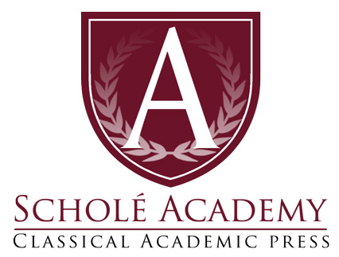
St. Athanasius: ‘On the Incarnation’

Summer Quarter
2022

Eligible Students:
This book club is for 11th and 12th grade students with a desire to grow in their knowledge of theology, philosophy, logic, and rhetoric.

Club Dates: Begin Thursday, June 16, 2022; running through Thursday, August 11, 2022.
Club Times: 11:00AM-12:30PM EST every Thursday (minus break week of July 14)
Instructor: Ben Cook
E-mail: benkylecook@gmail.com

Schedule:

Club Sessions Dates:
Classes will take place on Thursdays 11:00am — 12:30pm (EST) for 8 weeks on the following dates:

June (3): 16, 23, 30
July (3): 7, 21, 28
August (2): 4, 11

*Please note the above dates and times are the anticipated class sessions for this course. However, all dates are subject to change as the instructor’s circumstances might dictate (e.g. illness, family emergency). Any classes canceled by the instructor will be made up at an alternate time designated by the instructor.

Required Text:
The required text is On the Incarnation: Saint Athanasius, from the SVS Press Popular Patristics series. The text can be purchased on the SVS website here: https://svspress.com/on-the-incarnation-english-only/
Club Description:

In this summer club we will read and discuss the classic work of Patristic theology On the Incarnation, by St. Athanasius of Alexandria. In this work, St. Athanasius unfolds the logic, coherence, and salvific purpose of the incarnation: God becoming man in the Person of Jesus Christ, in order that man might participate in Divine Life. The goal of this club will be to increase understanding of dogmatic Christian theology, and how philosophy and logic have been, and can continue to be, deployed in its favor. Each meeting we will discuss the literary, philosophical, and rhetorical features of the assigned portion of the text for that week, with especial attention to the logical structure of St. Athanasius’ reasoning.

Student Expectations

Students are expected to show up and actively participate in weekly virtual discussions. Respectful and charitable dialogue with your peers, and with the instructor, are also essential. Everyone in our virtual classroom ought to exemplify, to the best that we are able, the fruits of the Spirit in how we treat each other. If, after repeated exhortation, a student continues to be disruptive or rude, the instructor reserves the right to remove the student from the meeting.

The Virtual Classroom:
We will be using the free online “virtual classroom” software provided by Zoom, one of the leading companies that provides such software. The virtual classroom will provide students with interactive audio, text chat and an interactive whiteboard in which texts, diagrams, video and other media can be displayed and analyzed. We will provide students with a link (via email) that will enable students to join the virtual classroom.

Specific information regarding the technology used by Scholé Academy (including required technology) can be found by visiting the Technology in the Classroom section of the Student Parent Handbook.

About the Instructor:

Ben Cook is a PhD candidate in philosophy at Syracuse University, and tutor at Scholé Academy. He specializes in the philosophy of religion, and loves to explore how faith and reason complement and illuminate one another. When not doing philosophy, he enjoys reading the Church Fathers, hiking, playing basketball, and playing the guitar.

