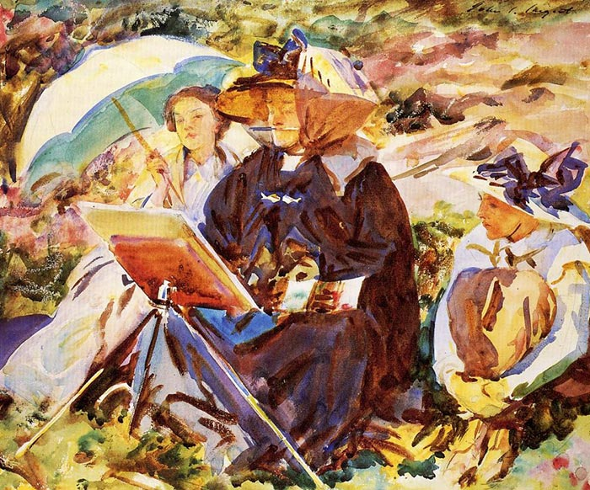

Observational Painting from Life: (Watercolor or Pastel)
1-week Summer Workshop
July 18-22

Section: 9am – 11am M, T, W, R, F

Teacher: Sean Oswald MFA
www.seanoswald.com
email: soswald.scholeacademy@gmail.com
phone: 513.828.9490

Join me for a week of observational painting from life. Choose if you would like to work in watercolor or pastel as we explore the subjects of still life and landscape painting. This will be a relaxed way to dip your toes into the wonderful world of observational painting.

During our course time together we will learn how to paint observationally, both from the landscape and still life. There will be time set aside to discuss our paintings and the work of historical life painters. We will begin and work on our paintings in class, but due to time and technology limitations, paintings may need to be worked on and finalized outside of workshop hours. When we meet, I will take time to give individualized direction and demonstrations that will show you how to set up your subjects and work. I also will set aside time for extended demonstrations so that you can observe how I approach a similar subject.

Painting 1: Still Life Painting
*** This is a sample of how it could go during the course. Specifics will vary depending on the circumstances that arise. There will be no grades given for this course and the completion of paintings will be the responsibility of the student.***

Monday
- Introduction to workshop and materials
- Material exploration and tests
- Picture studies of Cezanne watercolor still life paintings
  - 2 picture studies
  - Master copy still life painting

- Introduction to project #1 Still Life painting
  - How to select your still life objects
  - Setting up your still life
  - Composition considerations (rule of thirds)
  - (Homework- select objects and have ready to set up for course 2)

Tuesday
- Set up still life and materials
- Begin sketching out the composition
  - Composition studies. X4 thumbnails
- Begin the still life painting composition
- Work on still life and receive feedback

Wednesday
- Demonstration of working on still life painting
  - Beginning a painting.
  - Developing the block in stage
  - Color and space with paint
- Continue working on our still life painting
  - Develop the block in stage
  - Color glazes and layering/ combining color
- Finishing and details.
- *** If painting is not completed. Please finish the painting outside workshop time. ***

Painting 2: Landscape

Thursday
- Short Reflection on our paintings.
  - Give and receive feedback from teacher and peers on things well done and suggestions on what could improve for the next painting.
- Introduction to landscape painting
  - Color, light, and space.
  - Trees, sky and foliage
  - “Drawing, line, mass and defining space”

- Introduction to Project #2 Landscape Painting
  - How to select your “viewpoint”
  - Materials and how to set up
  - Composition
  - Homework (select your view and get ready to be set up for next class.)

Friday
- Hour 1
  - Set up in front of landscape view (in person ideally. From photo reference if necessary)
  - Drawing
    - Thumbnail sketches
    - Composition
  - Composition on painting
  - Develop first layers of color “block -in”
  - Take photo reference

- Hour 2
  - Set up and materials
  - Demonstration of painting a landscape
  - Work on our landscapes
  - Interspersed with teacher feedback and critique
  - Develop color and details
  - Finish paintings
    - If time, we will have a reflection portion where we can talk about the process.
    - If students do not complete paintings, they may continue to work outside of class on their work.

