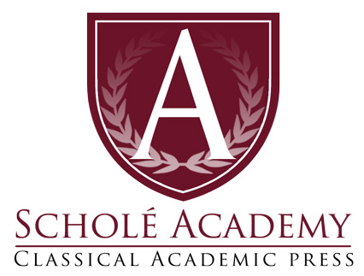
Introduction to Watercolor Painting

Spring Semester
Academic Year 2022/23

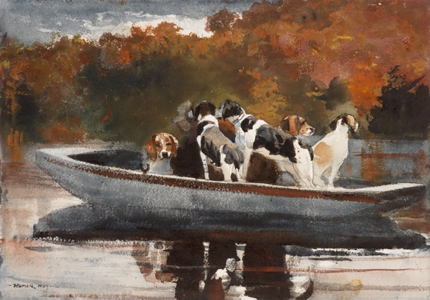

Winslow Homer, Dogs in a Boat, 1889

Eligible Students:
Rising 7th - 12th graders: Previous painting or drawing experience is not necessary for this course. We will begin with foundational skills and slowly build in complexity. A sense of wonder, creative courage, and perseverance are beneficial postures for flourishing in this course.

Class Start Date: Tuesday, January 23, 2023
Orientation Session: Week of January 20, 2023
End date: May 26, 2023
Section 1 Class Times: Tuesdays and Thursdays: 9:30- 10:45 (EST)
Instructor: Mr. Sean Oswald
E-mail: soswald.scholeacademy@gmail.com

Schedule for Introduction to watercolor painting:

Class Sessions Dates:
Classes will take place on Tuesdays and Thursdays for 16 weeks and 32 classes *
*Please note the above dates and times are the anticipated class sessions for this course. However, all dates are subject to change as the instructor’s circumstances might dictate (e.g. illness, family emergency). Any classes canceled by the instructor will be made up at an alternate time designated by the instructor.
Introduction to watercolor painting Course Map:

Quarter 1
- Introduction to watercolor materials
- Color theory and watercolor charts
- The watercolor sketchbook- John Singer Sargent and travel paintings
- Fruit paintings and still life
Quarter 2
- Landscape painting
- Master copies and study
- Winslow Homer and Genre scenes
- Final project

Office Hours: In addition to scheduled class times, I will be available to meet with students and parents by appointment to answer questions or review class material.

Required Course Materials:
Materials
- Set of drawing pencils
- Kneaded eraser
- Watercolor Sketchbook
- Pencil sharpener
- Blue painters tape
- Watercolor stretching board
- Set of watercolor paints
- Watercolor palette
- Several watercolor brushes of varying sizes (round, flat, filbert.)
- Water cup
- Watercolor paper pad 9” x 12”
- 2 x Watercolor paper sheets for projects
- Rags or paper towels

Miscellaneous
- Set of colored pencils
- Micron pens or other ink pens
- Watercolor stretching tape
- Apron to keep clothing clean
- Small spray bottle
- Masking fluid

Brushes
You will want a variety of long-handled oil/acrylic paint brushes. Look for “round,” “flat,” and “filbert” styled brushes. You should have a few larger brushes (up to an inch wide) as well as a handful of smaller brushes.

Introduction to watercolor painting Course Description:

Working with watercolors can be exciting and dynamic. Though it’s a medium known for it’s challenges, through familiarity and practice it can be harnessed to create beautiful effects: luminous color glazes, an immediacy and sensitivity that parallels drawing, and intuitive fluid and poetic mark making.
We will begin by gaining a sense of familiarity with the watercolors through a variety of exercises and material experiments. Then we will explore the full range of colors through various color charts and lessons on color theory. This will help provide a grounding from which to begin our studies of a handful of artists who were able to master the materials. Master copies and the study of our artists will be an ongoing feature of our class. We will become familiar with the artists and their artworks through extensive study of particular images, as Charlotte Mason would call “picture studies,” and engage in the artistic tradition of copying their work on a regular basis. Partially for this reason we will practice the habit of keeping a sketchbook, where we can take notes, copy artists’ work, do material tests, and make watercolor sketches throughout the duration of the course.
In addition to our studies of art history and great artists, a keen sense of observation about the world around us will be vigorously encouraged. By taking the position of an observer we will show reverence to God by admiring the goodness and beauty of the created world. With patience we will learn to paint from what God has created, applying the principles of composition to frame and organize our images in order to convey our ideas through watercolor paintings.
Join me this semester as we explore the wonderful world of watercolor painting!
*** Our class time will be comprised of demonstrations, individual instruction, work-time, and class discussion. Students do not need any prior art experience. The class will start simple dealing with foundational principles. Course material will gradually build in complexity. Students will practice thinking like an artist. They will engage in the whole creative process from generating ideas, making intentional decisions with each aspect of their work, and reflecting on what they have made.

Student Expectations

Attitude:
Students are to come to class prepared with an attitude of:
  - Humility
  - Respect
  - Vulnerability
  - Patience
  - Attentiveness
  - Eagerness to grow

Growth Mindset:
Learning a new skill is challenging and we will never start out knowing exactly how to make things look the way we want them. If you’ve never drawn before, you will not start out with a masterpiece. This is okay! Failure is good and part of our learning process. Grow patience with yourself and have the perseverance to continue through the discomfort and you may see success come. Success may look like progress and not perfection. “The perfect is the enemy of the good.” Work towards maintaining a good attitude and engage in the process. “Become who you are becoming.”

In the Classroom:
Students are expected to arrive to class on time with their needed materials prepped and ready to use. Students are expected to listen attentively and participate actively in class discussions and exercises. Each individual is responsible for staying up to date with classwork/assignments and for taking the initiative to reach out when in need of help.

Unless due to emergency or illness, students are expected to communicate absences with me at least a full day prior to the class in question. Unexcused absences and tardiness will affect the student’s class participation grade.

Student Evaluation: Grading

***Syllabi will be provided at the beginning of projects so that the student will know what is expected for excellent grades.

Student Evaluation: Mastery Portrait

At the completion of this course cum laude students will be able to…
- Operate successfully in a studio setting and care for their materials
- Complete all of the assigned projects and exercises
- Come to class ready to learn and engage in the process of art-making.
- Will be active in class discussions and will be able to follow directions well.
- Will be curious and eager to learn.
- Articulate different types of compositions and set up compositions of their own
- Critique their own and other’s art in an informed manner
- Maintain a sketchbook
- Create original paintings and drawings

Student Evaluation: Assignments, Types & Weights

Students will be evaluated in the following categories:

1.) Sketchbooks (10%)
  - Each student is expected to maintain a sketchbook for the year to develop ideas and practice.

- Studio participation and in class Exercises (30%)
  - Showing up and working
  - Art making, critique, thinking, reading, discussing.

- Homework (10%)
  - Reading, writing, reflection, out of class exercises
  - Sometimes we will have homework, though it will not be the same as your homework in other classes. This mainly means that you need to get still life objects, photo references, finishing a reflection from class, etc.

- Projects (50%)
  - Major projects will be completed during the semester. Timelines will be given when projects are given.

Student Evaluation: Academic Dishonesty

Students will spend most of the class creating original pieces of art. Claiming someone else’s work as your own is a serious and punishable offense. A plagiarized assignment will result in a failing grade.

The Virtual Classroom:

We will be using the free online “virtual classroom” software provided by Zoom, one of the leading companies that provides such software. The virtual classroom will provide students with interactive audio, text chat and an interactive whiteboard in which texts, diagrams, video and other media can be displayed and analyzed. We will provide students with a link (via email) that will enable students to join the virtual classroom.

Specific information regarding the technology used by Scholé Academy (including required technology) can be found by visiting the Technology in the Classroom section of the Student Parent Handbook.

Students will submit documents by scanning and uploading them to their personal computer, then submitting those files of their work to the designated Schoology assignment folder.

About the Instructor:

Sean Oswald holds a Master of Fine Arts (MFA) in Painting and Drawing from the University of Cincinnati and a Bachelors degree in arts education from Miami University, Ohio. Before attending graduate school, Sean studied painting and drawing at the Carriage House Atelier with Garin Baker learning the “alla prima” style. His work combines both traditional and contemporary practices with a focus on still life, landscape, portraiture and figure painting. His work has been exhibited both nationally and internationally and hangs in collections around the United States. Sean has over ten years experience teaching in a variety of contexts including the college level, K-12 public schools, Classical schools, homeschools, and privately and he also serves as the upper school fine arts teacher at Live Oak Classical School. Currently Sean works out of his home studio in Waco, Texas where he lives with his wife Hilary and their two daughters Beatrice and Josephine.

Sean is incredibly grateful for the opportunity to help foster the artistic gifts of others and to point them back to God in worshipful reverence.

